**Mini Project Report on**



**RICE PLANT DISEASE PREDICTION**

**USING**

**DEEP LEARNING**



**Submitted in partial fulfillment of the requirement for the award of the degree of**

**BACHELOR OF TECHNOLOGY**

**IN**

**COMPUTER SCIENCE & ENGINEERING**

**Submitted by:**

**Student Name**  **University Roll No.**

**RUDRAKSH AGARWAL 2021907**

***Under the Mentorship of***

**Prof. (Dr.) Manoj Diwakar**

**Professor**



**Department of Computer Science and Engineering**

**Graphic Era (Deemed to be University)**

**Dehradun, Uttarakhand**

**January-2025**



**CANDIDATE’S DECLARATION**

I hereby certify that the work which is being presented in the project report entitled **“Rice Plant Disease Prediction using Deep Learning”** in partial fulfillment of the requirements for the award of the Degree of Bachelor of Technology in Computer Science and Engineeringof the Graphic Era (Deemed to be University), Dehradun shall be carried out by the under the mentorship of **Prof. (Dr.) Manoj Diwakar, Professor**, Department of Computer Science and Engineering, Graphic Era (Deemed to be University), Dehradun.

Name University Roll No.

RUDRAKSH AGARWAL 2021907

**Table of Contents**

|  |  |  |
| --- | --- | --- |
| **Chapter No.** | **Description** | **Page No.** |
| Chapter 1 | Introduction | **1-2** |
| Chapter 2 | Literature Survey | **3-4** |
| Chapter 3 | Methodology | **5-7** |
| Chapter 4 | Result and Discussion | **8-9** |
| Chapter 5 | Conclusion and Future Work | **10** |
|  | References | **11** |

**Chapter 1**

**Introduction**

* 1. **Background**

Rice is one of the most popular crops in India and the world’s most significant crop. In the year 2024-25, the total rice production is at a record 527.6 million tons which is about 1.5 percent larger than 2023-24[1]. Among all the rice producing countries of the world, India itself produced 119.93 million metric tons of rice. But on the other hand, the diseases of rice cause about 10-30 percent loss of the total production annually [2]. Among many rice diseases, those causing the major rice yield loss every year include the bacterial blight, Brown spot, Leaf smut, sheath blight and many more [3]. Traditionally, Farmers use methods like crop rotation, proper water management, balanced fertilization and make use of locally adapted rice varieties to prevent and control crop exposure to rice diseases.

* 1. **Importance of Disease Detection**

Detection of rice plant disease is important because it helps us to maintain the quality and contributes to food security. This also helps in reducing the yield and economic losses. Traditional methods of disease detection are complex, more time consuming and less accurate as they depend on visual observations and basic laboratory tests, while modern methods use advanced technologies and methods like molecular diagnosis and imaging techniques which gives more accurate results and takes less time.

* 1. **Role of Deep Learning in Image Based Systems**

Deep Learning, a branch of machine learning which is itself a subset of Artificial Intelligence, has completely transformed the image-based systems in the field of agriculture by allowing them to detect the diseases in an automatic and more accurate manner. Deep learning techniques are more efficient in terms of speed, scalability and cost-effectiveness. Transfer learning along with deep learning, by using models like VGG16, MobileNet or ResNet, gives better results.

* 1. **Convolutional Neural Networks**

Neural Networks, a subset of deep learning, is also known as the heart of all the deep learning algorithms. These are layered networks which extract features from the input data. These are basically ANN’s or Artificial Neural Networks, which are particularly known as convolutional neural networks.

Convolutional neural networks contain three main layers: Input Layer, Hidden Layer & Output Layer. The Hidden Layer is further sub-divided into convolutional Layer, Activation layer such as ReLU, Pooling Layer (Max Pooling or Min Pooling) and Fully Connected Layer.

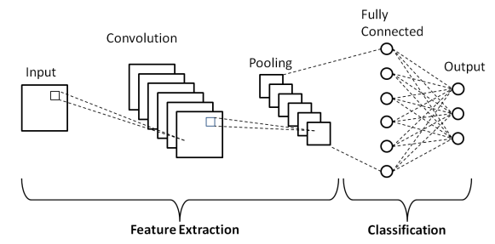

**Fig 1.1 Convolutional Neural Network [4]**

* 1. **Problem Statement**

It is being observed that manual rice disease detection lacks precision and depends on the observer’s understanding. Also, if the disease is not identified at a particular stage, it becomes difficult to control it which leads to huge loss to the farmers. The aim of this project is to develop a deep learning model which is efficient to predict rice diseases with maximum accuracy and high precision.

* 1. **Objectives**

The main Objectives of the rice plant disease prediction using deep learning are:

**(a) Aim:** Develop a rice leaf disease prediction model using deep learning for timely detection of diseases using image categorization.

**(b) Preprocessing:** Data Augmentation methods are applied and a pretrained VGG16 model is used with custom layers and transfer learning.

**(c) Evaluation:** Evaluate the model based on the performance on both training and validation sets. The model’s accuracy and efficiency make it more suitable for real world scenarios.

**Chapter 2**

**Literature Survey**

A Literature survey of the rice plant disease prediction using deep learning includes research and implementation of various models on different datasets used in some previous studies stated that rice leaf disease detection has great importance in the field of agriculture. Some of them are:

In research conducted by GK Sagarika, SJ Krishna Prasad and S Mohana Kumar [5], they have used image processing and convolutional neural networks to classify rice(paddy) plant diseases. They have gained the dataset from the agricultural image repositories and worked on it. They have also stated that, due to convolutional neural network’s fast convergence rate and highly accurate results, they got an accuracy of 94.12 percent, when number of epochs is 20 and the learning rate is 0.0001. They also gained confusion matrix as a parameter of evaluation.

They have integrated this model to an IOT platform, that provides fast recommendations for pesticides use to control disease exposure to crop which improves the yield and reduce losses.

In a study conducted by Varun Pramod Bhartiya, Rekh Ram Janghel and Yogesh Kumar Rathore [6], they have focused on various machine learning models for simple classification of rice leaf diseases. In this research from all the available datasets, they have used the UCI and IPM dataset. After the feature extraction, they have trained the datasets using different classification models like Kernel Naïve Bayes, Ensemble Naïve Bayes, Cubic Support Vector Machine, Linear Support Vector Machine, Quadratic Support Vector Machine. Among all these models Quadratic Support Vector Machine Classifier gives an accuracy of 81.8 percent.

Also, they have got good results which fulfilled their required expectations.

In previous research completed by P. Issac Ritharson, Kumudha Raimond, X. Anitha Mary, Jennifer Eunice Robert, Andrew J [7], they have done deep feature-based rice leaf disease classification using deep learning. They have incorporated deep learning along with transfer learning for predicting rice leaf diseases more accurately. For this, they have used a dataset of around 5932 images, further classified into 9 categories, including healthy and various rice diseases. They have applied data augmentation techniques on the dataset and designed a customized convolutional neural network model which in combination with transfer learning models like VGG16, Xception and ResNet50 gives an exceptional accuracy of 99.94%. The dense feature extraction gives such high results which helps in more accurate predictions.

In an IEEE published research paper, authored by Kawcher Ahmed, Tasmia Rahman Shahidi, Syed Md. Irfanul Alam and Sifat Momen [8], as this paper is published from Bangladesh so they focused their research based on those circumstances only. They have used a very small dataset of about 480 images which they have divided in 90:10 ratio for training and testing. They have trained the dataset on various machine learning algorithms like K-Nearest Neighbour (KNN), Decision Tree (J48), Naïve Bayes and Logistic Regression. Among all these models they have observed that Decision Tree give highest results after 10-fold cross validation is applied. Decision Tree model gives an accuracy of 97% on the test dataset.

**Chapter 3**

**Methodology**

**3.1 Dataset**

In this project we have used the Rice Leaf Disease dataset [], which is already divided into training set and validation set. Both train and validation dataset contain 2100 and 528 images respectively, i.e., the total dataset size is about 2628 images. These two datasets are further classified into six categories(each), namely, bacterial_leaf_blight, brown_spot, healthy, leaf_blast, leaf_scald, narrow_brown_spot. All the six categories consist of 350 images each for the train set and 88 images each for the validation set. All the images are in JPG format and their resolution is 1600x1600 pixels.

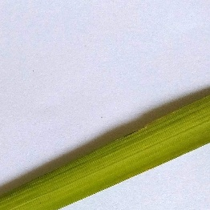 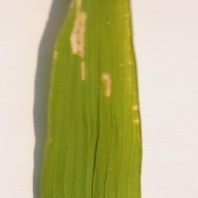 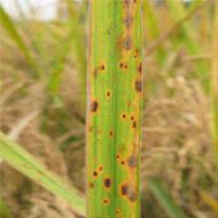

(a) Healthy Leaf (b) Bacterial Blight (c) Brown Spot

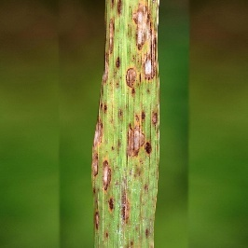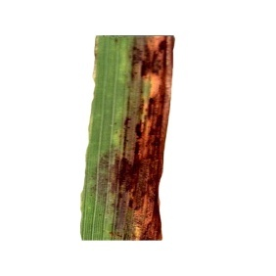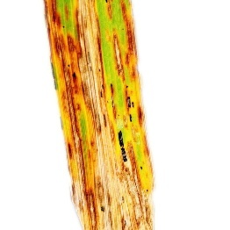

(d) Leaf Blast (e) Leaf Scald (f) Narrow Brown Spot

**Fig 3.1**

**3.2 Data Preprocessing**

In this project to improve the performance and generalizability of the model, we have implemented various data preprocessing techniques like for training data, data augmentation is done by using the ImageDataGenerator class. Also, we have rescaled all the pixels to the range [0,1], which ensures normalized data input for the model.

On the other hand, for the validation data, we have only performed rescaling to ensure smooth evaluation.

**3.3 Model selection**

In this project, we are working with a combination of convolutional neural networks and transfer learning, so we’ll select a pre-trained convolutional neural network called VGG16.

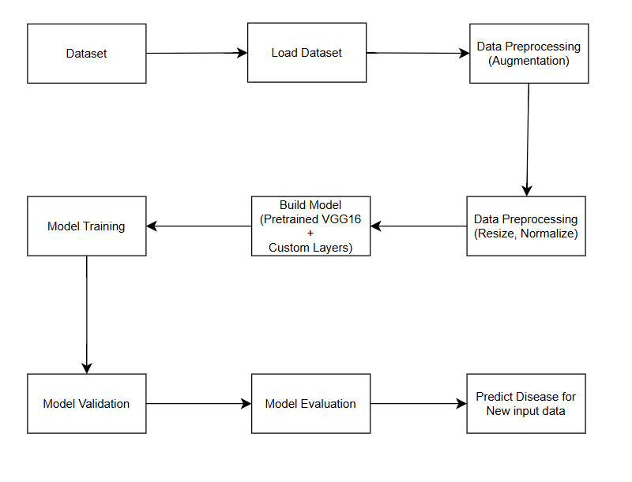

**Fig 3.2 (Block Diagram of Entire Work)**

**3.3.1** **Feature Extraction**

We have used VGG16, a pretrained neural network, without its topmost fully connected layers for feature extraction. And the remaining layers are freeze to store the learned feature form the ImageNet dataset, which prevents the model from overfitting.

Instead of the topmost fully connected layers, we have added some of the custom layers:

(1) Flattening layer: a layer that converts the special feature maps into 1-D vectors.

(2) Fully connected layer: a layer with 512 neurons and ReLU (Rectified Linear Unit) activation.

(3) Dropout layer: a layer which is added for regularization, decreasing the chances of overfitting.

(4) Output layer: An Output layer is also added at the end which uses a constraint called softmax activation and 6 units, one for each class.

**3.3.2 Model Compilation**

For model compilation we have used the Adam optimizer with the following constraints:

(1) Learning Rate = 0.0001

(2) loss = ‘Categorical_crossentropy’

(3) metrics = [‘accuracy’]

**3.4 Model Training & Model Fitting**

We have trained the model multiple times for different epochs values using the training and validation data generators.

After training the model for multiple times, we have observed that the model learns to accurately predict or classify the rice leaf images into the six predefined categories.

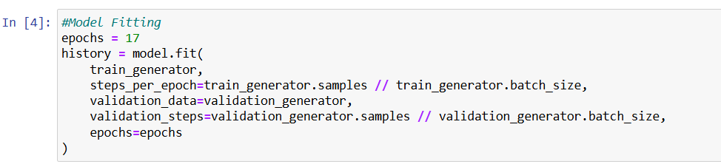

**Fig 3.3**

**3.5 Model Evaluation**

After the training stage, the model comes under evaluation on the validation set. We have use metrics such as validation loss and validation accuracy to determine the model’s ability to perform better predictions on unseen data.

We have also visualized training and validation metrics over epochs using plots of model accuracy and model loss.

**3.6 Testing with Random Images**

We have added a test function in our model through which we can predict the category of randomly given rice leaf image. The testing function converts the image into the suitable input format as expected by the model. The model predicts the class with which the image belongs or similar to it.

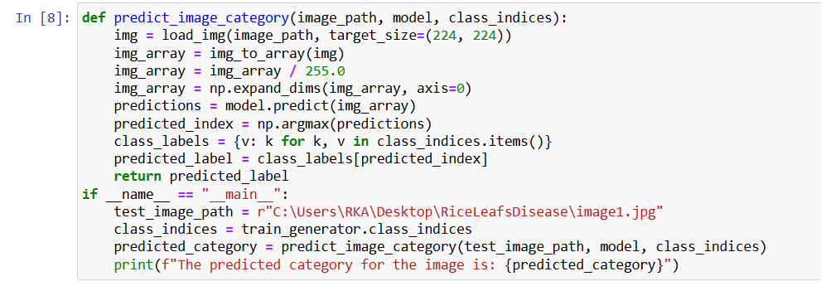

**Fig 3.4**

**Chapter 4**

**Result and Discussion**

In this project, we have observed the results in four stages:

**4.1 Model summary**

In the first stage of model summary, we have got a small visualization of the dataset and the model parameters.

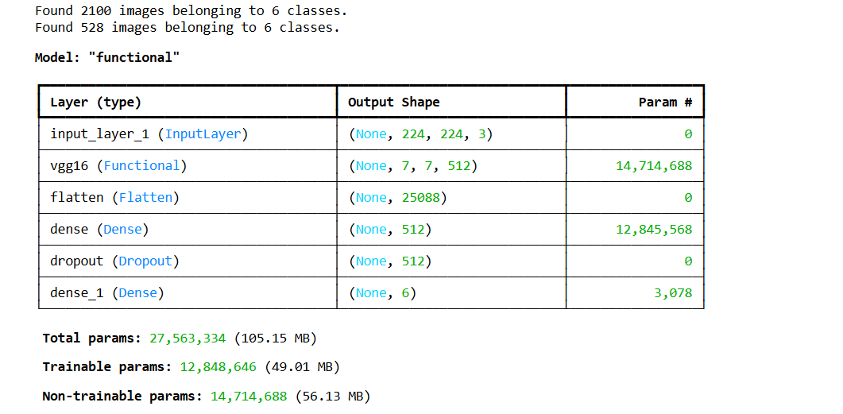

**Fig 4.1**

**4.2 Epoch performance**

After the training process, when we are evaluating the model, we have observed that when the number of epochs is around 15 at that stage the model gives 85% validation accuracy and 35% validation loss.

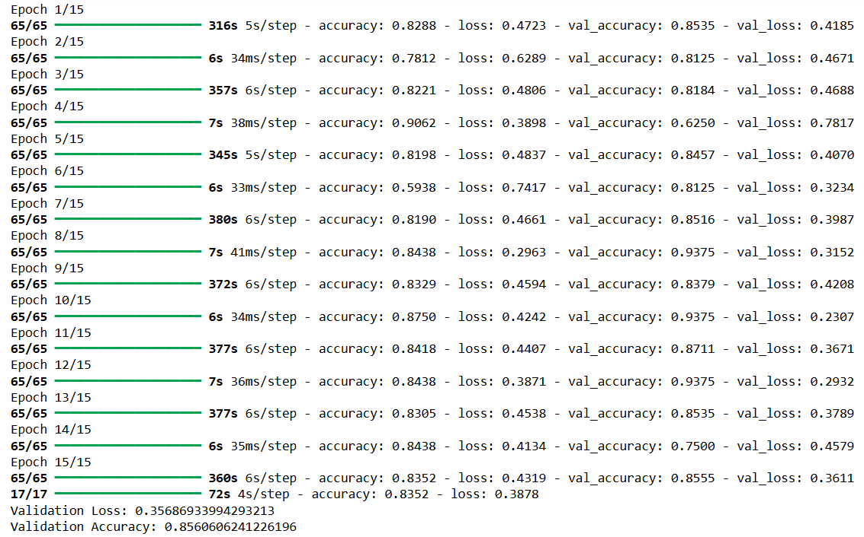

**Fig 4.2**

**4.3 Accuracy Plot and Loss Plot**

After the evaluation process, we have visualized all the training and validation metrics over epochs using Accuracy plot and Loss Plot.

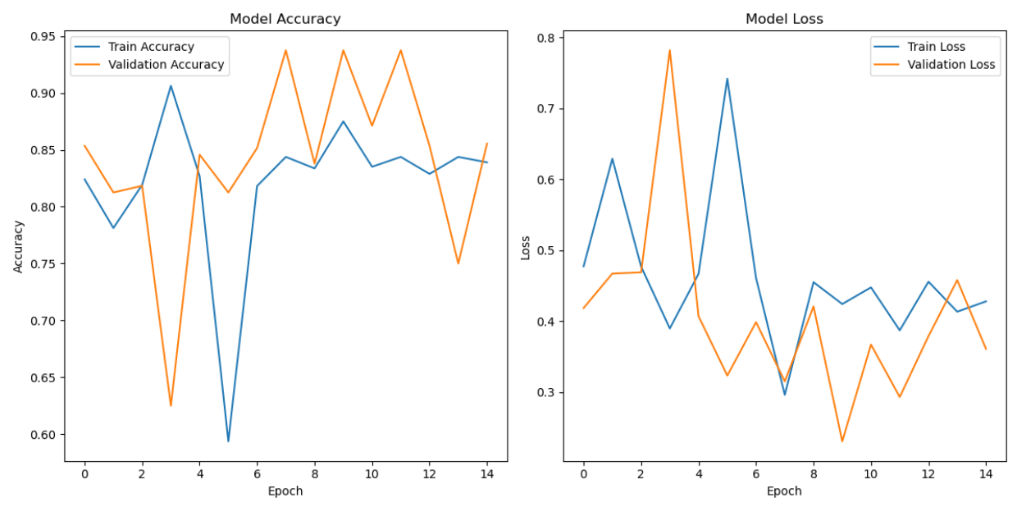

**Fig 4.3**

**4.4 Testing Function Results**

We have tested the model on various random images using the test function, which give the predicted category of the image as output.

**Image:**

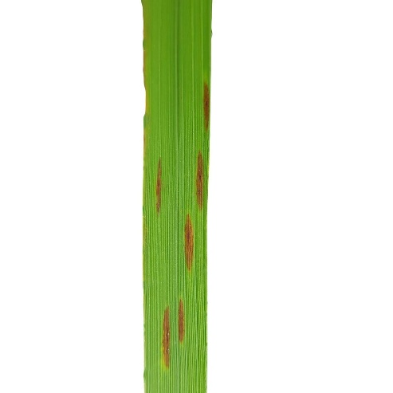

**Fig 4.4**

**Output:**



**Fig 4.5**

**Chapter 5**

**Conclusion and Future Work**

**5.1 Conclusion**

In this project, a rice plant leaf disease prediction model is developed using deep learning along with transfer learning, which provides the best evaluation metric results using the pretrained VGG16 architecture with custom layers. This project is generalized to work on any rice leaf dataset. It also contains a test function through which we can test it on random rice leaf images, which enables it for real time disease detection.

The model gives results with a validation accuracy of 86% and validation loss of 35%, when the number of Epochs is 15. The test function classifies the random input image from the six known categories. The use data augmentation prevents the model from the situation of overfitting and helps in making it generalized for all rice leaf datasets. As the accuracy is below the expectations, there is a space for change under which we can extract good results and make the system automated and faster, so that the end users, here farmers, will get correct predictions and they are able to reduce physical and economic losses.

**5.2 Future Work**

While the current accuracy is good and we are getting good prediction but still, there is a space for change through which we can get good results. For this, we can use specialized models or we can combine two or more models to give better results. Specialized models like ResNet and MobileNet are suitable to get high accuracy. Also, we can Transformers like BIET and VIT, which can give better predictions.Agriculture is vast field for research, in this context we can implement multiple this to increase the performance of the models:

**5.2.1 Dataset Expansion**

In some cases, Expansion of Datasets gives good results as both quality and quantity of the dataset is important.

**5.2.2 Advance Data Preprocessing and Model Tuning**

We can also Preprocess data in more ways so that we can extract more insights from it. This helps the model to predict better and makes a gradual increase in the accuracy. Also, we can tune the parameters of the model as per future requirements.

**5.2.3 Deployment and Training**

Once we get a more optimized model, we can deploy it so that it can be used by the non-technical user easily for the real-world scenarios and we can take feedback from them.

**References**

[1] Childs, N., USDA’s World Agricultural Outlook Board, & USDA, Economic Research Service. (2024). Rice Outlook: June 2024 [Report]. <https://downloads.usda.library.cornell.edu/usda-esmis/files/dn39x152w/sn00cp136/h702rx17t/RCS-24E.pdf>

[2] He, Z., Zhang, Z., Valè, G., Segundo, B. S., Chen, X., & Pasupuleti, J. (2023). Editorial: Disease and pest resistance in rice. Frontiers in Plant Science, 14. <https://doi.org/10.3389/fpls.2023.1333904\>

[3] Wikipedia contributors. (2024, April 8). List of rice diseases. Wikipedia. <https://en.wikipedia.org/wiki/List_of_rice_diseases>

[4] Figure 1. Schematic diagram of a basic convolutional neural network. . . (n.d.). ResearchGate. https://www.researchgate.net/figure/Schematic-diagram-of-a-basic-convolutional-neural-network-CNN-architecture-26_fig1_336805909

[5] G. K. Sagarika, S. Krishna Prasad and S. Mohana Kumar, "Paddy Plant Disease Classification and Prediction Using Convolutional Neural Network," 2020 International Conference on Recent Trends on Electronics, Information, Communication & Technology (RTEICT), Bangalore, India, 2020, pp. 208-214, doi: 10.1109/RTEICT49044.2020.9315634.

[6] Bhartiya, V. P., Janghel, R. R., & Rathore, Y. K. (2022). Rice leaf disease prediction using Machine learning. 2022 Second International Conference on Power, Control and Computing Technologies (ICPC2T), 1–5. https://doi.org/10.1109/icpc2t53885.2022.9776692

[7] P. Isaac Ritharson, Kumudha Raimond, X. Anitha Mary, Jennifer Eunice Robert, Andrew J, Deep Rice: A deep learning and deep feature-based classification of Rice leaf disease subtypes, Artificial Intelligence in Agriculture, Volume 11,2024, Pages 34-49,

ISSN 2589-7217, https://doi.org/10.1016/j.aiia.2023.11.001

(https://www.sciencedirect.com/science/article/pii/S2589721723000430)

[8] K. Ahmed, T. R. Shahidi, S. M. Irfanul Alam and S. Momen, "Rice Leaf Disease Detection Using Machine Learning Techniques," 2019 International Conference on Sustainable Technologies for Industry 4.0 (STI), Dhaka, Bangladesh, 2019, pp. 1-5, doi: 10.1109/STI47673.2019.9068096

[9] Rice Leafs Disease Dataset. (2022, June 9).

Kaggle. https://www.kaggle.com/datasets/dedeikhsandwisaputra/rice-leafs-disease-dataset